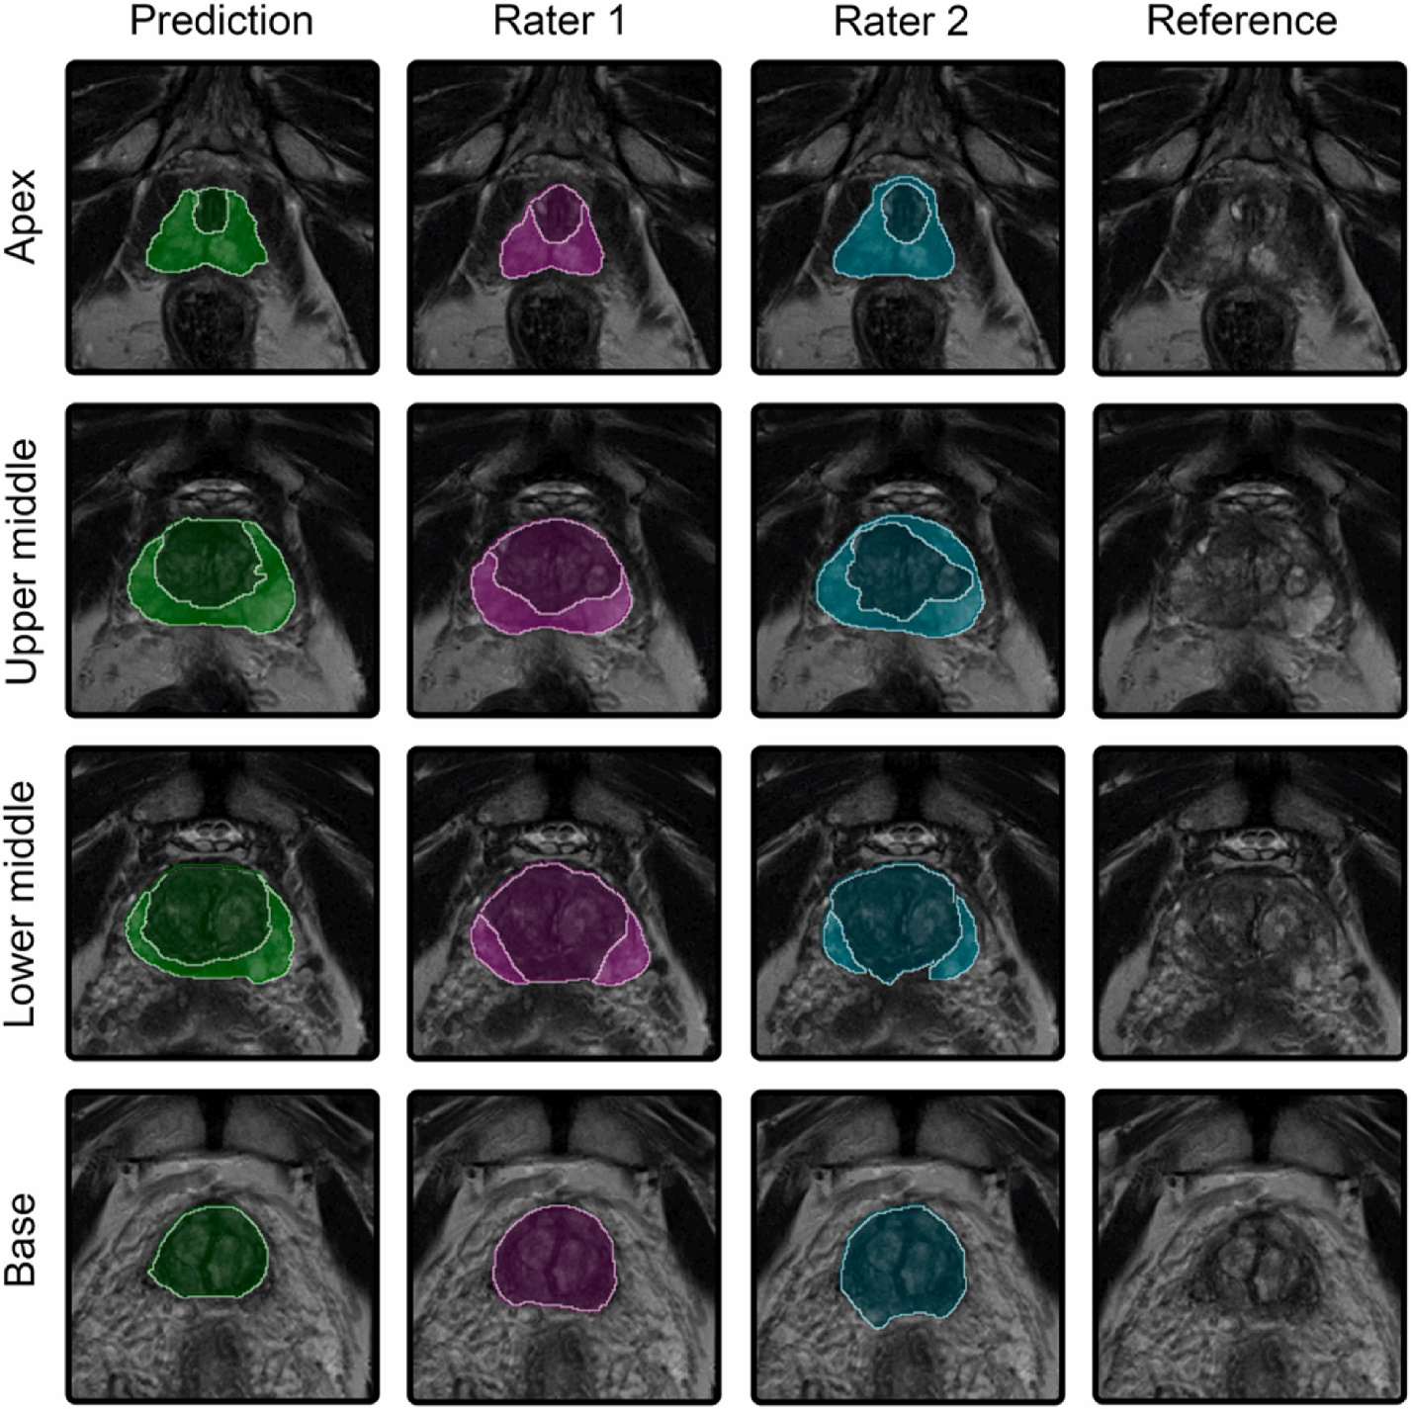**Python Assignment: Refining a Pre-trained Deep Learning Model for Prostate Gland Segmentation on MRI**

**Background:** Prostate cancer is usually detected and localized with an MRI scan. Prostate MRI has multiple sequences of which T2 and ADC are commonly used. One of the fundamental tasks in diagnosis and treatment planning of prostate cancer is to segment out the prostate gland (shown on T2 sequence in the figure).

There are existing deep learning models for prostate gland segmentation on MRI. A popular model trained on a [public dataset](https://www.sciencedirect.com/science/article/abs/pii/S0010482522005789) (D1) is available on the [MONAI Model Zoo](https://monai.io/model-zoo.html) by navigating to ‘Prostate MRI anatomy’. This code can also be accessed [here](https://api.ngc.nvidia.com/v2/models/nvidia/monaihosting/prostate_mri_anatomy/versions/0.3.4/files/prostate_mri_anatomy_v0.3.4.zip). But a lot of deep learning models suffer from batch effects which implies that deep learning models do not generalize well to other datasets.

**Task 1:** We have a new dataset (D2) which is a subset of 80 studies from a public dataset [here](https://indiana-my.sharepoint.com/:f:/g/personal/rshirad_iu_edu/EsBfStV0X0BOqlbsx57L2GIBZzZMHOr27oe-lljK-18eaA?e=zuUMzH). Each patient has 4 files - T2, ADC, gland (which is prostate gland mask) and tumor.

├── patient_001/

│ ├── T2.nii.gz

│ ├── ADC.nii.gz

│ ├── gland.nii.gz

│ └── label.nii.gz

└── ...

Your task is to:

1. Test how the pre-trained model works on D2 by itself.
2. Fine-tune the pre-trained model to D2 to improve segmentation performance.

You can limit yourselves to just using T2 as the image and gland as the mask for the purpose of this task. We want to see your understanding of batch effects, image pre-processing, knowledge of deep learning, medical imaging through this assignment.